Jaime Warburton
jaime.warburton@gmail.com
607-262-3960

5’7”
Contralto/Mezzo (D3 – A5)
Mover

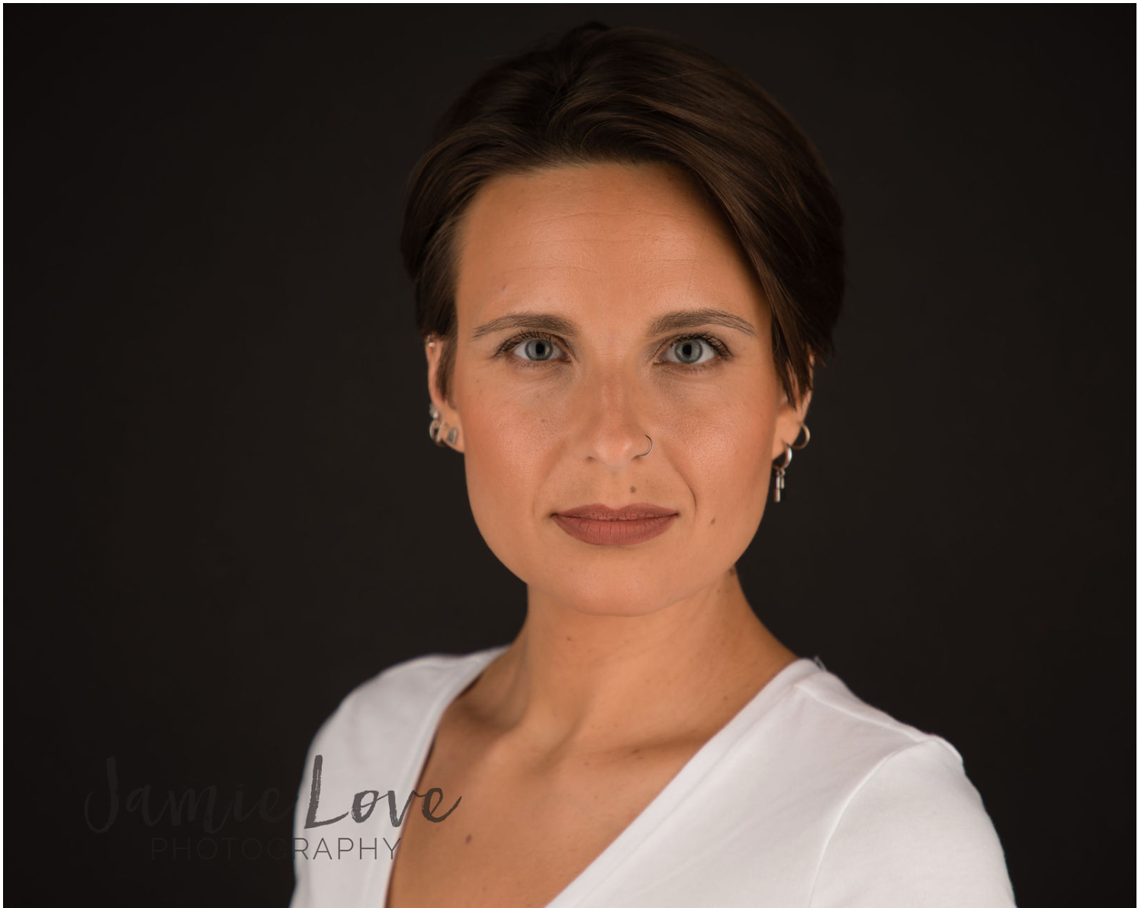

Musical Theatre/Opera
A Year with Frog and Toad Track One WoW Productions 2021
Katrina Marie WoW Productions 2019
Oklahoma! Ensemble/soloist Triphammer Arts 2018
The Magic Flute Chorus Opera Cowpokes 2010
Once Upon a Mattress Queen Aggravain MPS Theatre 2000
Babes in Arms Jennifer MPS Theatre 1999
Godspell Disciple MPS Theatre 1998

Theatre
The Wedding Show Broom Cherry Arts 2023
Lysistrata Kleonike On the Verge 2003
As You Like It Duchess Frederick MPS Theatre 1997
The Diviners Luella MPS Theatre 1996

Screen
Wheatfield with Crows (feature) Dr. Saxon Ithaca, NY 2023
Windows (short) The Handler Ithaca, NY 2023
Phone Date (Coke commercial) Mom Ithaca, NY 2023
Friday Film Five (Coke commercial) Extra Ithaca, NY 2020
Crackers (pilot) Ensemble Ithaca, NY 2002
The Sherriff of Kit’s Run (short) Female Lead Ithaca, NY 2005

Choral Experience
Cornell Chorale Alto 2022
CRS Barn Studio Choir Alto 2022
Dorothy Cotton Jubilee Singers Alto 2015
Bella Voce (soloist) Alto/Soprano II 2011-2014
Fingerlakes Women’s Chorale(soloist) Alto/Alto II 2008-2011
Sarah Lawrence Chamber Choir Tenor 2005-2007
D’Angelo Conservatory Choir Alto 1998

Additional Skills
Ballet, flute/recorder/tin whistle, improv, stage combat

Training
Non-major acting at Ithaca College with Cynthia Henderson and Barbara Anger; Non-major flute at Ithaca College; Voice at D’Angelo Conservatory; Ballet with Ithaca Ballet

